Let’s apply what you’ve learned about data-centric architecture and see how it works in a real organization.

 STU is a national university. Here are some **quick facts:**

* STU has more than 45,000 graduate and undergraduate students.
* STU is updating its software system for new students, diplomas, tuition administration, and loan administration.

**What’s the Business Problem?**

STU wants to define action items for student categories based on certain rules. These action items come from a communication policy established by the board of directors. For example, “If a student loan is approved, then we must send an email to the student, their parents or tutors, and update our administrative tuition records accordingly.”

Let’s analyze this situation!

1. Imagine that there are many student categories at STU: graduate, undergraduate, a student that applied for a loan, a student whose loan has been approved, a student aged 16 to 21, a student whose age is over 21, an international student, etc.
2. A student can belong to multiple categories.
3. Action items defined by the board are executed for a group of student categories, usually, if they happen together. For example, “If the student is foreign **and** applied for a loan, then do X, Y, Z.”
4. We do not want to rewrite the code each time the board updates or creates action items for a certain category.

It's a perfect scenario for a data-centric architecture: there must be a table for action items upon categories, and the system must look up each table entry in order to act.

**What's the Solution?**

Now, let’s see the detailed architecture diagram for this solution:

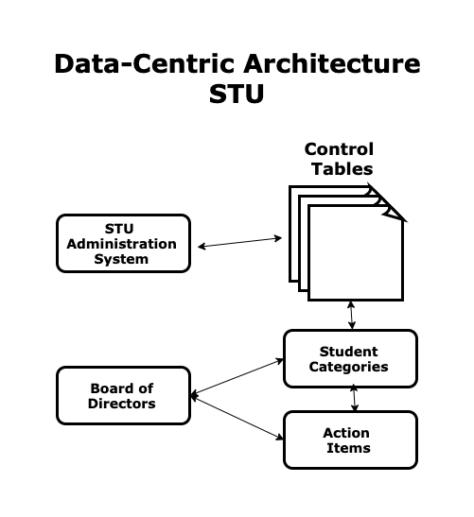

STU data-centric architecture

Let’s explain each component of the ERP system:

* **Administrative system:** This is the system developed for STU.
* **Control tables:** This is a set of tables that define the action items the system must take for each category according to board decisions.
* **Board of directors:** This is a group of directors, trustees, or advisors in a university or college that defines the strategy of the institution to enroll students and maintain an adequate curriculum and a desired level of quality.
* **Categories:** This a set of student categories.
* **Action items:** This is a set of actions to be executed for a certain category.